METHODOLOGY

*Conceptual Framework*

Figure 4.1 Conceptual Framework

Based on the Conceptual Framework as shown in Figure 4.1. The input is dependent on the face of the person that the camera sees. The process of camera tracking would be composed of algorithms, classification and value mapping. The OpenCV library (python version) is used to do image processing. Moreover, the Cascade Classifier class is used for classifying the face. It is used to detect objects in a video stream. The device uses serial communication in order to communicate with the computer. This is done by receiving the data via the communication port of the computer. Through image processing, the servo’s speed is mapped to the location of the face found in the camera’s resolution. Finally, the output would be detecting and tracking the face of the user.

*Proposed Design*

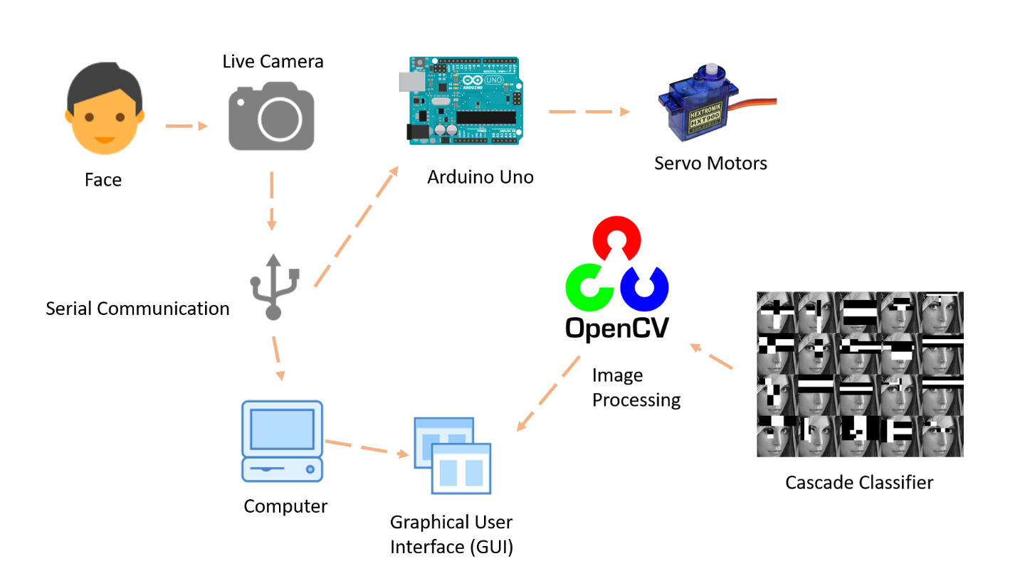

Figure 4.2 Schematic Representation of the Camera Tracking

Based on the Schematic Representation of the Camera Tracking as shown in Figure 4.2. The face of the user would be the input data of the system in which the camera would capture it live stream. The live camera would be connected through the COM (communication) Port of the computer and data would be transmitted via Serial Communication. The camera can be viewed on the Graphical User Interface (GUI). Also, the GUI Software would be programmed using Python Language and using the OpenCV library for Image processing. In the image processing, the live stream captured by the camera would be processed by detecting the face of the user using a cascade classifier. The haarcascade_frontalface_default would be the cascade classifier of the software. This would determine the frontal face in the live stream. This would then compute the center of the face and the mid-point would be sent to the Arduino Microcontroller via Serial Communication. After the data is sent, this point values would be mapped to be the speed of the servo motors. The speed of the servo motors would be controlled by the Arduino in which the values are dependent on the mid-point location of the face.